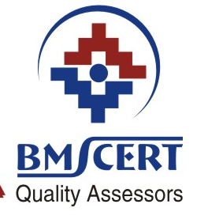
BMS Certification Pvt. Ltd.
317, Aggarwal Modern Bazar, C-33, Lawrnece Road, New Delhi-110 035, India
Ph.: 27101017

Delhi
01.04.2016

Change of standard ISO 9001:2008 to ISO 9001:2015

Dear customer,
In September 2015 standard ISO 9001:2015 was issued. This standard fully replaces ISO 9001:2008 standard.
How to proceed:
- It is necessary to get standard ISO 9001:2015
- It is necessary to adapt management system to ISO 9001:2015 requirements. Here are the new and significantly changed requirements:
- Clauses of standard are divided differently as in the old standard, requirements are sorted in Clauses 4 to 10. New and significantly changed requirements are in Clauses no. 4.1, 4.2, 4.3, 4.4.1 (indicators related to performance), 5.1, 6.1, 6.2, 7.1.6, 8.5.5, 8.5.6
- Cancel references to version ISO 9001:2008 within internal documentation
- It is necessary to provide training of management, related employees and internal auditors regarding to changed requirements

BMS Certification procedure:
From 01.06.2016 will BMS conduct planned surveillance audits according to requirements of new standard. If the audit´s result is positive the certificate issued according to the old standard will be replaced by certificate according to ISO 9001:2015 with the same validity date as at the original certificate. If the nonconformities are issued against ISO 9001:2015 requirements the time for their elimination will be until the end of transition period. At the moment there is transition period running. During this period both of these standard´s versions are valid. The transition period ends 14.09.2018. All certificates issued according to standard ISO 9001:2008 become invalid after this date.

Regards,

Ashok Kumar Goyal
Director of Certification Body

